TECAN Conversion to ECHO (pseudocode)

// commands:

// A – aspirate

// D – dispense

// W – wash (clean up for TECAN)

// R – reagent dispense

// general format:

// **Reagent**

Guess:

Command_type;source_name;;Source_type;Tip_number;tip_?;destination_type;destination_type;range(wells_distr);vol(wells_distr);enzyme;num_reuse_tips;?;?;

Actual:

R;**AspirateParameters**;**DispenseParameters**;Volume;LiquidClass;

NumOfDitiReuses;NumOfMultipleDispensers;Direction[;ExcludeDestWell]*

**AspirateParameters**

= SourceRackLabel;SourceRackId;SourceRackType;

SourcePositionStart;SourcePositionEnd;

**DispenseParameters**

=

DestinationRackLabel;DestinationRackId;DestinationRackType;

DestinationPositionStart;DestinationPositionEnd;

Main Parameters for Aspirate + Dispense:

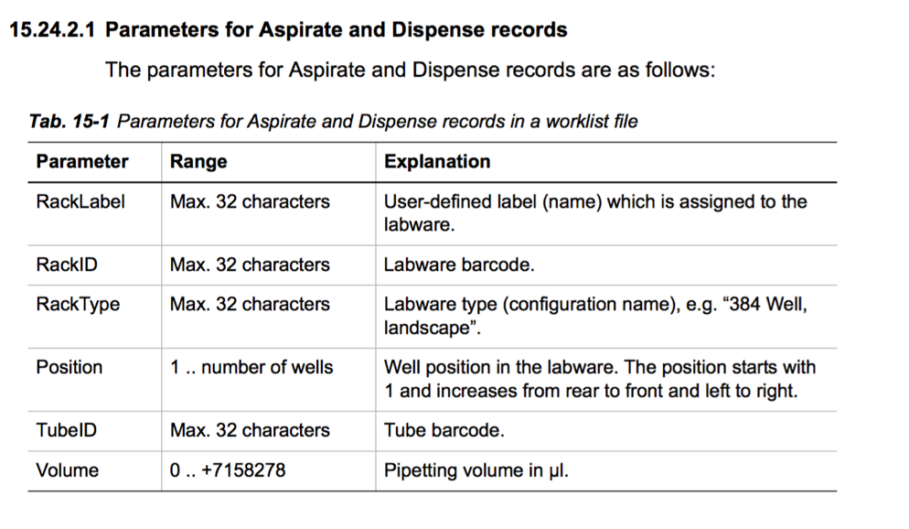

Main parameters for Reageant Distribution records

(aspirate / dispense):

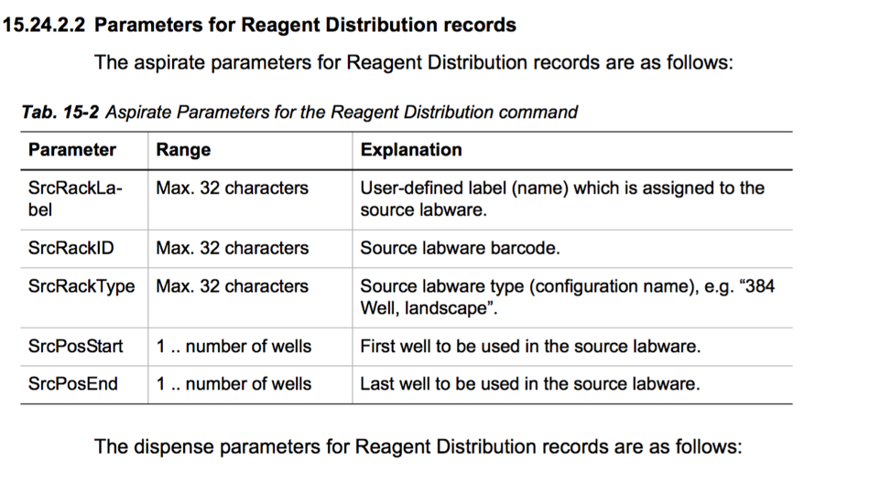

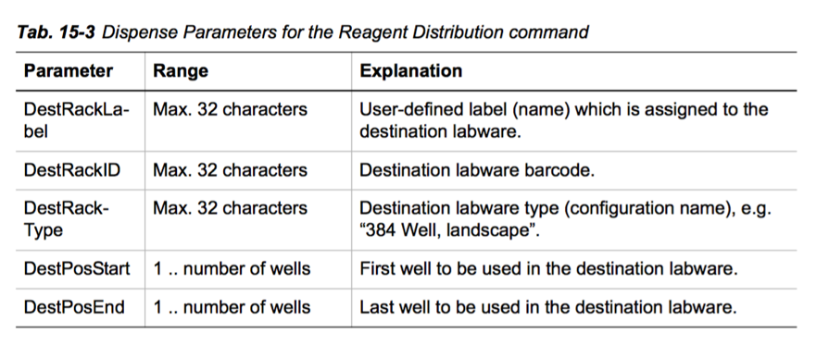

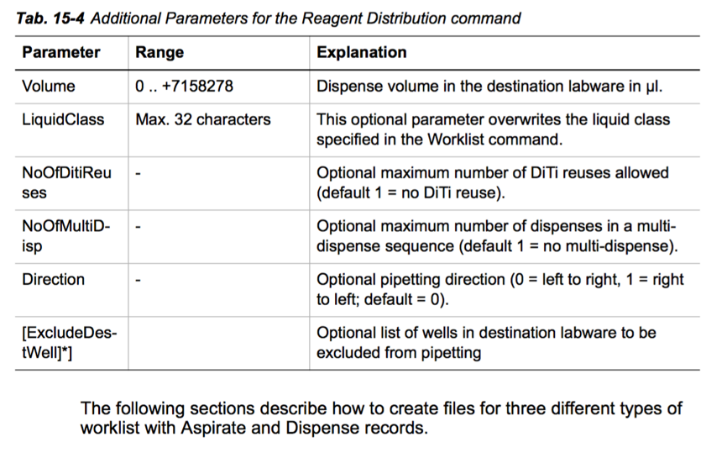

// **Aspirate**:

Guess:

Command_type;source_name;;source_type;;source_location;;volume

Actual:

A;RackLabel;RackID;RackType;Position;TubeID;Volume

// **Dispense**:

Command_type;source_name;;source_type;;source_location;;volume

Attempted translation to English (for psuedocode):

(try the first 21 commands and see if Luis approves)

1. Dispense the reagent plate1 from the source 96 well microplate, from tip 1 with quantity 1, onto the wells 1 to 33 on the destination 96 well microplate, with ENZYME 1000 at volume of 6.0 liters;
2. Dispense the reagent plate1 from the source 96 well microplate, from tip 2 with quantity 2, onto the wells 34 to 66 on the destination 96 well microplate, with ENZYME 1000 at the volume of 6.0 liters;
3. Dispense the reagent plate1 from the source 96 well microplate, from tip 3 with quantity 3, onto the wells 67 to 96 on the destination 96 well microplate, with ENZYME 1000 at the volume of 6.0 liters;
4. Aspirate on source setup plate1 onto destination 96 well microplate 20 with volume of 2.0 liters;
5. Dispense on source plate1 in 96 well microplate 1 with a volume of 2.0 liters;
6. TECAN robot wash step;
7. Aspirate on source setup plate1 onto destination 96 well microplate 1 with volume of 2.0 liters;
8. Dispense on source plate1 in 96 well microplate 1 with a volume of 2.0 liters;
9. TECAN robot wash step;

10)Aspirate on source setup plate1 onto destination 96 well microplate 9 with volume of 2.0 liters;

11)Dispense on source output plate1 onto destination 96 well microplate 1 with volume of 2.0 liters;

12)TECAN robot wash step;

13)Aspirate on source setup plate1 onto destination 96 well microplate 12 with volume of 2.0 liters;

14) Dispense on source output plate1 onto destination 96 well microplate1 with volume of 2.0 liters;

15) TECAN robot wash step;

16) Aspirate on source setup plate1 onto destination 96 well microplate 16 with volume of 2.0 liters;

17) Dispense on output plate1 onto destination 96 well microplate 1 with volume of 2.0 liters;

18) TECAN robot wash step;

19) (reservoir ignore command);

20) Dispense on output plate1 onto destination 96 well microplate 1 with volume of 4.0 liters;

21) TECAN robot wash step;

____________ (extension) ___________________________________

22) Aspirate on source setup plate1 onto destination 96 well

microplate 20 with volume of 2.0 liters;

23) Dispense on output plate1 onto destination 96 well microplate 3 with volume of 2.0 liters;

24) TECAN robot wash step;

25) Aspirate on source setup plate1 onto destination 96 well microplate 1 with volume of 2.0 liters;

26) Dispense on output plate1 onto destination 96 well microplate 3 with volume of 2.0 liters;

27) TECAN robot wash step;

28) Aspirate on source setup plate1 onto destination 96 well microplate 9 with volume of 2.0 liters;

29) Dispense on output plate1 onto destination 96 well microplate 3 with volume of 2.0 liters;

30) TECAN robot wash step;

31) Aspirate on source setup plate1 onto destination 96 well microplate 14 with volume of 2.0 liters;

32) Dispense on output plate1 onto destination 96 well microplate 3 with volume of 2.0 liters;

33) TECAN robot wash step;

34) Aspirate on source setup plate1 onto destination 96 well microplate 16 with volume of 2.0 liters;

35) Dispense on output plate1 onto destination 96 well microplate 3 with volume of 2.0 liters;

36) TECAN robot wash step;

37) (reservoir ignore command);

38) Dispense on output plate1 onto destination 96 well microplate 3 with volume of 4.0 liters;

39) TECAN robot wash step;

40) Aspirate on source setup plate1 onto destination 96 well

microplate 20 with volume of 2.0 liters;

41) Dispense on output plate1 onto destination 96 well

microplate 4 with volume of 2.0 liters;

42) TECAN robot wash step;

43) Aspirate on source setup plate1 onto destination 96 well

microplate 1 with volume of 2.0 liters;

44) Dispense on output plate1 onto destination 96 well

microplate 4 with volume of 2.0 liters;

45) TECAN robot wash step;

Additional information / documentation:

Parameters for the Reagent Distribution method:

|  |  |  |
| --- | --- | --- |
| Parameter | Range | Explanation |
| Volume | 0 … + 7158278 (long) | Dispense volume in the destination labware in μl. |
| LiquidClass | Maximum 32 characters (varchar) | This optional parameter overwrites the liquid class specified |
| NumOfDitiReuses | - | Optional maximum number of DiTi reuses allowed (default 1 = no DiTi reuse) |
| NumOfMultiDisp | - | Optional maximum number of dispenses in a multi-dispense sequence (default = 1 no multi-dispense) |
| Direction | - | Optional pipetting direction (0 = →, 1 = ←, default = 0) |
| [ExcludeDestWell]*] | - | Optional list of wells in destination labware to be excluded from pipetting |